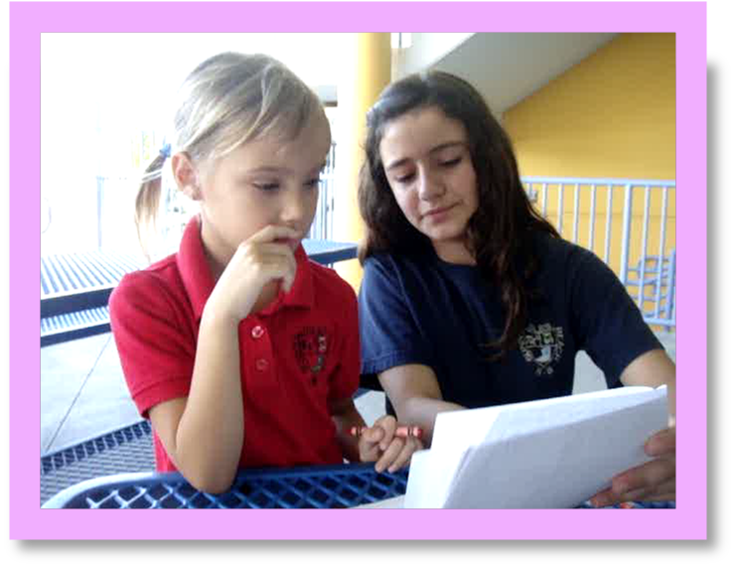
“Partner Up for ESOL”

Patti Ward
Norman S. Edelcup Sunny Isles Beach K-8
201 182nd Street
Sunny Isles Beach. Florida
Mail Code: 0092
edforus@aol.com

For information concerning IMPACT II opportunities, Adapter and Disseminator grants, please contact:

The Education Fund
305-892-5099, Ext. 18
e-mail: Lvalle@educationfund.org
website: www.educationfund.org

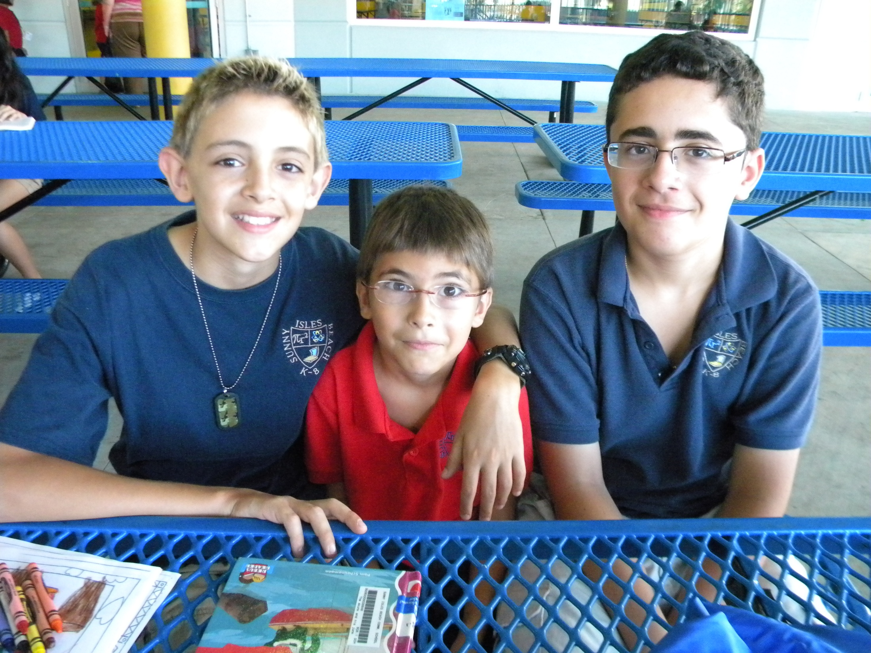

Tables of Contents

Goals and Objectives 3-6

Course Outline/ Overview 6-7

The Project 7-6

Resource List 7-10

Lesson Plans 10

Reflection and Journaling Ideas 11-16

Reference and Web Resources 17

Acknowledgement 18

Partner Up for ESOL

Curriculum Areas:

ESOL, Language Arts and Reading

Goals

“Partner Up for ESOL” is a program to assist students in the primary grades that are ESOL level 1 or 2 in adjusting to their new surroundings and at the same time improve the students’ Reading, Writing, and English skills. Based on the “Accelerated Reader Program,” the primary level ESOL students will improve their “instructional reading level (IRL)” after implementing “Partner Up for ESOL.” The program will also assist the older students in adjusting to middle school. Easing the transitional period of time will support the students in settling into the routines of middle school. Working with younger children gives the older students an opportunity to feel a sense of responsibility that helps them feel good about themselves.

Objectives

The following objectives are based on the 2010 Next Generation Sunshine State Standards (Common Core) – English Language Arts
Obtained from the following website: http://www.corestandards.org/the-standards/english-language-arts-standards

Grade 1 English Language Arts Reading Standards

Key Ideas and Details
- RL.1.1. Ask and answer questions about key details in a text.
- RL.1.2. Retell stories, including key details, and demonstrate understanding of their central message or lesson.
- RL.1.3. Describe characters, settings, and major events in a story, using key details.

Craft and Structure
- RL.1.4. Identify words and phrases in stories or poems that suggest feelings or appeal to the senses.
- RL.1.5. Explain major differences between books that tell stories and books that give information, drawing on a wide reading of a range of text types.
- RL.1.6. Identify who is telling the story at various points in a text.

Integration of Knowledge and Ideas
- RL.1.7. Use illustrations and details in a story to describe its characters, setting, or events.
- RL.1.8. (Not applicable to literature)
- RL.1.9. Compare and contrast the adventures and experiences of characters in stories.

Range of Reading and Level of Text Complexity
- RL.1.10. With prompting and support, read prose and poetry of appropriate complexity for grade 1.

English Language Arts Standards Writing
Grade 1

Text Types and Purposes
- W.1.1.. Write opinion pieces in which they introduce the topic or name the book they are writing about, state an opinion, supply a reason for the opinion, and provide some sense of closure.
- W.1.2. Write informative/explanatory texts in which they name a topic, supply some facts about the topic, and provide some sense of closure.
- W.1.3. Write narratives in which they recount two or more appropriately sequenced events, include some details regarding what happened, use temporal words to signal event order, and provide some sense of closure.

Production and Distribution of Writing
- W.1.4. (Begins in grade 3)
- W.1.5. With guidance and support from adults, focus on a topic, respond to questions and suggestions from peers, and add details to strengthen writing as needed.
- W.1.6. With guidance and support from adults, use a variety of digital tools to produce and publish writing, including in collaboration with peers.

Grade 6 English Language Arts Standards Writing

- W.6.2. Write informative/explanatory texts to examine a topic and convey ideas, concepts, and information through the selection, organization, and analysis of relevant content.
  - Introduce a topic; organize ideas, concepts, and information, using strategies such as definition, classification, comparison/contrast, and cause/effect; include formatting (e.g., headings), graphics (e.g., charts, tables), and multimedia when useful to aiding comprehension.
  - Develop the topic with relevant facts, definitions, concrete details, quotations, or other information and examples.
  - Use appropriate transitions to clarify the relationships among ideas and concepts.
  - Use precise language and domain-specific vocabulary to inform about or explain the topic.
  - Establish and maintain a formal style.
  - Provide a concluding statement or section that follows from the information or explanation presented.
- W.6.3. Write narratives to develop real or imagined experiences or events using effective technique, relevant descriptive details, and well-structured event sequences.
  - Engage and orient the reader by establishing a context and introducing a narrator and/or characters; organize an event sequence that unfolds naturally and logically.
  - Use narrative techniques, such as dialogue, pacing, and description, to develop experiences, events, and/or characters.
  - Use a variety of transition words, phrases, and clauses to convey sequence and signal shifts from one time frame or setting to another.
  - Use precise words and phrases, relevant descriptive details, and sensory language to convey experiences and events.
  - Provide a conclusion that follows from the narrated experiences or events.

Production and Distribution of Writing
- W.6.4. Produce clear and coherent writing in which the development, organization, and style are appropriate to task, purpose, and audience. (Grade-specific expectations for writing types are defined in standards 1–3 above.)
- W.6.5. With some guidance and support from peers and adults, develop and strengthen writing as needed by planning, revising, editing, rewriting, or trying a new approach.
- W.6.6. Use technology, including the Internet, to produce and publish writing as well as to interact and collaborate with others; demonstrate sufficient command of keyboarding skills to type a minimum of three pages in a single sitting.

Research to Build and Present Knowledge
- W.6.7. Conduct short research projects to answer a question, drawing on several sources and refocusing the inquiry when appropriate.

Range of Writing
- W.6.10. Write routinely over extended time frames (time for research, reflection, and revision) and shorter time frames (a single sitting or a day or two) for a range of discipline-specific tasks, purposes, and audiences.

The Disseminator

Patti Ward is a graduate of Barry University, with a Bachelors of Science Cum Laude 1981. She received a Masters of Urban Education from F.I.U. in 1992. She has 28 years teaching experience in Miami- Dade County Schools. She has been selected 4 times for “Who’s Who of American Teachers”, selected as Chapter I teacher of the year, a directing teacher of 5 interns, Mint Mentor, NEST facilitator, a MetLife TNLI Fellow and has been awarded grants from The Education Fund Impact II grant, Citibank Success Fund grants, Cedar’s Medical Center grants, Donorschoose.org, Adopt a Classroom grants, Target grants and Weareteachers.com grants.

Course Outline and Procedures

Middle school students that are able to speak a foreign language are paired with first grade ESOL level 1 or 2 students with the same language to assist with reading and writing skills. The students read together once a week and assist them with writing. The older students journal and reflect with the younger students about their progress and session together. They also help the younger students on the computer when they have to take an "Accelerated Reading" test. Lending younger students a hand encourages and motivates the older students and aids them during a very crucial time of development. The older students create a DVD, PowerPoint, or scrapbook about all their experiences throughout the year and then they present this to the classes at the end of the school year. “What Works In School” Translating Research into Action, Marzano (2003) establishes the fact that one of the most important features of a school is to promote “self-discipline and responsibility”. “Partner Up for ESOL” has a positive affect on the students by intrusting them to work with younger students and establishes the confidence and responsibility they need during this critical developmental time.

The most important part for the older students is that this program establishes a classroom routine of daily reflecting and journaling. The older students are given a “daily reflection” which they are required to respond to in the same journal. The “daily reflection” that they are required to complete are usually related to a familiar subject such as; feelings, family, culture and or things that they could relate to from their daily lives. Many of the daily reflections that are posted are from the Reading/Language Arts text and the reflection relate to the “Theme” and/or stories the class is focusing on at the time. Sometimes, the students are asked to pretend they are a character in the story or the teacher gives them a “What if …” reflection encouraging higher order, critical thinking skills. As a daily part of the reading procedures, some of the students share their reflection for the day. Students are required to reflect in their personal journal after every session with their ESOL partner.

The Benefits

With guidance and support from older students, the younger students that do not have a strong grasp of the English language adjust quickly and improve their English skills. The older students are able to communicate and explain things to the younger students that ease the transition for the ESOL students. Working with younger students has a positive affect on the older students’ self-esteem. Lending younger students a hand encourages and motivates the older students. According to "Transition to A Middle Level School: What Kids Say," Middle School Journal, November, 1992“, one way middle school students describe this period is “when I first started the 6th grade I didn't know what to do or what to think. Teachers don't know about how hard it is for a sixth grader to feel good and how a lot of kids are scared of life.” Pairing ESOL students together will not only improve the younger students' language skills, reading scores and writing skills but it motivates the older students and improves their self esteem. As one of my sixth grade students stated "I wish I had a mentor when I came here from Russia." This program has a positive impact on all the students that are involved.

"Partner Up for ESOL" has a positive affect on both the older and younger students' emotional and academic achievement. What makes this program different from most “mentoring programs” is one key factor. This program not only helps the middle school students emotionally but this program enhances both the middle school students and the younger students academically. This program is unique because it addresses the needs of students that do not have the English language skills when they enter school. Teachers that work with ESOL students need all the help they can get and the older students are able to encourage and help the younger students adjust and thrive academically.

The Students

This project was designed so it can be adapted to almost any grade level and can fit the needs of the group depending on how in-depth the adaptor wants to go. One can choose to pair any primary grade with any intermediate to middle school grade students. For example one might select students from grades K-3 to pair with students in grades 4-8.

Evaluation

There are several ways the teacher can assess the students and the project. The teacher can evaluate the program through an attitude survey that should be administered prior to starting the project and at the end of the project to the students and teachers participating. The data collected from the surveys should be evaluated to see if there was a significant difference in the attitudes and feelings of the middle school students before they started the project. Both the primary grade teachers and the middle school Language Arts teacher can use the students’ journals and reflections as a means to evaluate the students’ progress in writing. The primary teachers can assess the students on their reading skills throughout the year using the “Accelerated Reader” program. The older students’ Language Arts teacher can evaluate the students’ projects they created for their partner, as well.
Overall Value

This project has a positive impact on both the older students and the primary grade ESOL students. Reading, reflecting and journal writing increases students’ reading and language arts skills and improves self-esteem. The primary students will improve their instructional reading level. By adapting this project, students’ desire to want to read and write will improve, which may result in an increase of students’ reading and writing skills, and ultimately impact his or her academic achievement.

Materials and Resources
All resources are listed in this packet. This project can be kept to a minimal amount of time and cost or can become extremely elaborate depending on the teacher’s and the school’s resources. Included in this packet are a list of suggested materials, journal ideas, references, and resources. Students used the media center, computer lab, classroom and homes to complete the end of the year presentation. "Accelerated Reader" program and “AR” books were used throughout the year from the media center. We met in either the media center, classroom and outside patio once a week. We used composition notebooks, crayons, pencils, video and digital cameras, and computers. However, the program does not necessarily need the video and digital cameras. Most schools already have the “Accelerated Reader” books and program, as well as, the computers needed. The only thing I purchased through my grants was a “Flip” camera, extra storybooks, primary and intermediate composition books, crayons and colored pencils.

Below are the items I recommend you order for this project. One may or may not need these items and can adapt this grant to meet your classroom needs. You do not necessarily have to purchase the items I did. I recommend that a teacher adapting this grant be creative and have fun with the project.

- 70 page Spirals and or Composition Books- I always purchase the 70 page spirals at the “Back to School Sale” at Target and usually pay $0.10 for each. These spirals are used for the students’ daily reflection/ journals.
- USB Flash Drives-You really need to price shop and compare. I obtained some from Office Depot at $4.95 with 1 GB of memory.
- Sets of “Accelerated reader” books. I placed bids on “Ebay” to obtain most of my sets and we used the ones in the media center, too.
- Digital camera or video camera-I used a “Flip” video camera that cost $109.00 at “Best Buy.”

Lesson Plans for Journaling

Journal writing can be incorporated right into your daily lesson for reading and language arts. Journal writing can be used as a warm-up prior to teacher instruction. Journal writing is as simple as posting the reflection on the board and having students write when they walk in the classroom in the morning during the time you need as a teacher to take attendance, collect homework, etc. Students should be given the opportunity to share their reflections, too.

Journal Writing Worksheets for 365 Days

The link below offers a journal writing worksheet for 365 days. Check this website out for some great writing ideas and lesson plans! The website’s name is “School Express” and you can search for writing and journal ideas. There are 365 pages of ideas to use all year round.

http://www.schoolexpress.com/fws/cat.php?id=2541

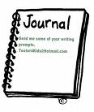

Journaling and Reflection Ideas
.
Attached other journal ideas I use and more! I posted a journal idea daily from the list and encouraged the students to write about themselves I also use several reflections that I created that go along with our Language Arts series.
Write about your family’s journey to America…
Write about your family’s favorite story they like to repeat over and over…
Write about who, what, where, when, and why your family came to America…
Write about the things that make your family unique…
Write about a time my family…
Write about a special family member…
Get inspired create a poem about your family…
Write about your family’s religions, beliefs and traditions…
Write about your family’s home country…
Write about a time when you were brave, or finish this sentence: I am brave because. .
Write about a time when you were helpful.
Write about something or things that you do well.
Write about three things that make you interesting.
Write about a time when you were honest.
Write about a time when you were dishonest.
Write about a time when you were helpful.
Write about something(s) that you do well.
Write about things that make you interesting.
Write about a time when you were honest.
Write about a time when you were dishonest.
Write about your best friends. Who are they? Why do you like them? What do you do together for fun?
What country would you like to visit? Why?
Write about the most exciting thing that ever happened to you.
Write about a time when you were nice to someone in your family.
Write about your home
Write about things you play with
Write about your favorite foods
Write about your school
Write about your family
Write about yourself (describe yourself or write about your interests)
Write about your friends
Write about a vacation
Write about your favorite activity
Write about your favorite candy
Write about your favorite toy
Write about what you do after the school day is over
Write about a favorite friend.
Write about a time when you were mean to someone in your family.
If you could have anything in the world what would it be?
Write about yourself. What color is your hair? What do you look like? Write details.
Write about an embarrassing moment. What happened? Who was there?
Write details about your life. Where were you born? Who do you live with? Where have you lived?
Write about your favorite animal.
Write about your favorite or least favorite foods. Why do you like them or dislike them?
Write about things you like to do. Why do you like them or dislike them?
Write about your favorite or least favorite sports. Why do you like them or dislike them?
Write about the people in your family. Do you have brothers or sisters? What are their names? Do you get along with them?
What makes you feel happy? Why?
What makes you feel sad? Why?
What makes you feel mad? Why?

Do you like music? If so, write about what kind of music you like and why you like it. What are your favorite songs or musical groups?
What are your favorite or least favorite movies? Why?
Write about your hobbies. Why do you like them?
Write about books you like to read. Or write about a book you are reading now. What is the book about? Who are the characters? Who are your favorite characters? Is it an information book or a story?
Write about things you like to write about. Do you like writing stories? What do you like better: writing imagination stories or true stories
Write about your favorite and least favorite things about school. Why do you like them or dislike them?
What holidays does your family celebrate (like Christmas, Kwanzaa, or Hanukkah)? What do you do on those holidays?
What are your favorite or least favorite colors? Why do you like them or dislike them?
Write about the nicest thing you have done for someone.
What is your favorite park? Where is the park and what do you like to do there?
Does your family go to church, synagogue, and temple? Write about it.
How do you celebrate your birthdays? Do you have a cake? Do you have a party? Do you run around and hang from the ceiling fan or light?
Do you have any favorite relatives? Like an uncle or aunt or grandpa? What do you do with them and why do you like them?
Write about the naughtiest thing you ever did. Did you get caught? How were you punished?
What is your favorite or least favorite season of the year? Winter? Spring? Summer? Fall? Why do you like or dislike them?
Do you have any pets? What are their names? What kind of animals are they? Why do you like them?
What do you do on Saturday mornings?
What do you do on Sunday mornings?
Have you been to any other states or countries? Where did you go? Why did you go there? What did you see or do there?
Do you have chores or jobs that you have to do at home? What are they? Why do you have to do them? Do you like doing them?
What do you like to do at home? Do you like to watch T.V.? Play? Read? Write?
Have you ever broken one of your bones? What did you break and how?
Did you ever have to get stitches? Where did you get them? Write about your accident.
What do you want to be when you grow up? Do you want to be a teacher? Fire Fighter? Doctor? Custodian? Why?
Write about your least or most favorite toy. Why do you like or dislike them? What do you do with them?
Write about the home you live in. Is it a house? Apartment? Trailer? How many rooms are there? What is your favorite room? What do you do there?
Who are your friends? What do you like to do with them to have fun?
Write about your neighborhood. Is it crowded? Is it in the city? Is it out in the country with no one around?

Write about what you think you are good at. Are you good a playing piano? Playing soccer? Why do you think you are good at these things?
Have you ever been camping? If so, write about one of your trips. Where did you go? What did you do? Who was with you?
Have you ever been chased by an animal? Write about the adventure. What kind of animal was it? What did it do? Why was it chasing you?
Do you like games? What is your favorite or least favorite game? Why do you like or dislike them?
Write about what makes you bored.
Write about what makes you have fun.
Have you ever rode on a plane, ship, or train? Where did you go? Did you like the ride?
When I look in a mirror I see…
If I were a character from (a story) I would have …
I challenge myself by….
I am a doer because I …
I am a dreamer because I.

References

http://www.nmsa.org/AboutNMSA/PositionStatements/TransitioningStudents/tabid/283/Default.aspx

http://www.crossagelearning.net/research-briefs.shtml

http://www.time.com/time/covers/1101010514/

http://www.billsgames.com/brain-teasers/

http://www.hvcn.org/info/kingpto/journal_prompts.htm

http://www.spiritual.com.au/articles/stories/creation_uk.htm

School Express at
http://www.teachervision.fen.com/writing/lesson-plan/3514.html

On Line Resources
http://www.educationfund.org/

http://www. donorschoose.org/

http://www.adoptaclassroom.com/

http://www.schoolexpress.com/fws/cat.php?id=2541

http://www.kidswriting.about.com

http://www.journals.about.com

http://www.kidskonnect.com/

http://www.factmonster.com/

http://www.readwritethink.org/lessons/lesson_view.asp?id=56

http://jc-schools.net/PPTs-la.html This website provides too many PowerPoint presentations for all grade levels on all areas of learning. A GREAT resource!

Thank You
The Education Fund
For
Sponsoring
“Partner Up for ESOL”
By
Patti Ward

